RED LION YOUTH FLAG FOOTBALL Age 4-5 Division * “THINK POSITIVE * BE POSITIVE”

* ALL PLAYERS MUST PLAY AT LEAST 50% OF EACH GAME
“Romans 10:9”
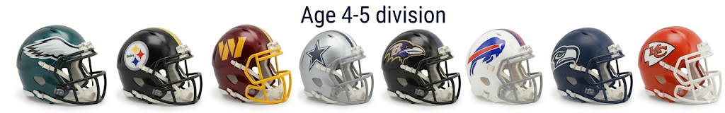
Age 4-5 Division
Week 1 * Arrive 1 hour prior to your scheduled time for practice
Date Time Home Team Away Team Field
- Sun 3/29/2026 12:45 pm Ravens Steelers Field 2B
- Sun 3/29/2026 12:45 pm Eagles Commanders Field 2C
- Sun 3/29/2026 12:45 pm Seahawks Cowboys Field 2D
- Sun 3/29/2026 12:45 pm Bills Chiefs Field 2E

4/5/26 WE are off on Easter Sunday * Happy Easter and Resurrection DAY!


Week 2 * Arrive 1 hour prior to your scheduled time for practice
- Sun 4/12/26 12:45 pm Seahawks Ravens Field 2B
- Sun 4/12/26 12:45 pm Bills Steelers Field 2C
- Sun 4/12/26 12:45 pm Commanders Cowboys Field 2D
- Sun 4/12/26 12:45 pm Chiefs Eagles Field 2E

RED LION YOUTH FLAG FOOTBALL Age 4-5 Division * “THINK POSITIVE * BE POSITIVE”
* ALL PLAYERS MUST PLAY AT LEAST 50% OF EACH GAME
“Romans 10:9”

Week 3* Arrive 1 hour prior to your scheduled time for practice
- Sun 4/19/2026 12:45 pm Chiefs Commanders Field 2B
- Sun 4/19/2026 12:45 pm Ravens Bills Field 2C
- Sun 4/19/2026 12:45 pm Steelers Cowboys Field 2D
- Sun 4/19/2026 12:45 pm Eagles Seahawks Field 2E

Week 4 * Arrive 1 hour prior to your scheduled time for practice
- Sun 4/26/2026 12:45 pm Bills Commanders Field 2B
- Sun 4/26/2026 12:45 pm Eagles Steelers Field 2C
- Sun 4/26/2026 12:45 pm Chiefs Seahawks Field 2D
- Sun 4/26/2026 12:45 pm Ravens Cowboys Field 2E

Week 5* Arrive 1 hour prior to your scheduled time for practice
- Sun 5/3/2026 12:45 pm Eagles Cowboys Field 2B
- Sun 5/3/2026 12:45 pm Ravens Chiefs Field 2C
- Sun 5/3/2026 12:45 pm Bills Seahawks Field 2D
- Sun 5/3/2026 12:45 pm Commanders Steelers Field 2E


*WE ARE OFF ON 5/10/26 HAPPY MOTHER’S DAY! HOPE ALL OF OUR MOM’s HAVE THE BEST DAY EVER!

RED LION YOUTH FLAG FOOTBALL Age 4-5 Division * “THINK POSITIVE * BE POSITIVE”
* ALL PLAYERS MUST PLAY AT LEAST 50% OF EACH GAME
“Romans 10:9”
Week 6* Arrive 1 hour prior to your scheduled time for practice
- Sun 5/17/2026 12: 45 pm Chiefs Steelers Field 2B
- Sun 5/17/2026 12: 45 pm Ravens Eagles Field 2C
- Sun 5/17/2026 12: 45 pm Seahawks Commanders Field 2D
- Sun 5/17/2026 12: 45 pm Cowboys Bills Field 2E


WE ARE OFF MEMORIAL DAY WEEKEND (May 24th) as we honor and remember those who served!

Week 7 * Arrive 1 hour prior to your scheduled time for practice
- Sun 5/31/2026 12:45 pm Ravens Steelers Field 2B
- Sun 5/31/2026 12:45 pm Eagles Commanders Field 2C
- Sun 5/31/2026 12:45 pm Seahawks Cowboys Field 2D
- Sun 5/31/2026 12:45 pm Bills Chiefs Field 2E

Week 8 - Final Week and Awards ( All teams play on this day.)

- Sun 6/7/26 12:45 pm Seahawks Ravens Field 2B
- Sun 6/7/26 12:45 pm Bills Steelers Field 2C
- Sun 6/7/26 12:45 pm Commanders Cowboys Field 2D
- Sun 6/7/26 12:45 pm Chiefs Eagles Field 2E

THANK YOU FOR BEING A PART OF OUR LEAGUE!
May God bless you and your family!
